PYTHON NOTES

Everyone has a few common questions when they want to learn something or do something, Here also same like that.

If a student wants to learn Python or another programming language, they will have the same questions.

• WHAT IS PYTHON?
• WHY PYTHON?
• WHERE PYTHON CAN USE?
• WHAT PYTHON CAN DO?
• HOW PYTHON WORKS?

WHAT IS PYTHON?

Python is now one of the most popular and widely used programming, Besides web and software development .It is an interpreted, object-oriented, high-level programming language.

WHAT IS PROGRAMMING?

Programming is the process of creating a set of instructions that tell a computer how to perform a task. Programming can be done using a variety of computer programming languages, such as Python, JavaScript and C++.

WHY PYTHON?
We have several reasons to say, "Why Python?"

In all of that, I'm gathering a few helpful uses.

- Career Opportunities and Salary.

Python language provides several job opportunities and promises high growth with huge salary prospects. Some of the big and renowned companies that use Python for their development are:



- Trending Programming Language.

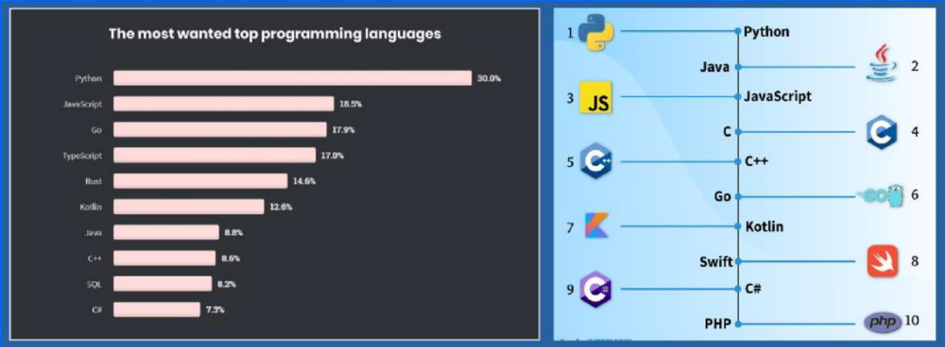

- Python is used by 50% of developers worldwide.

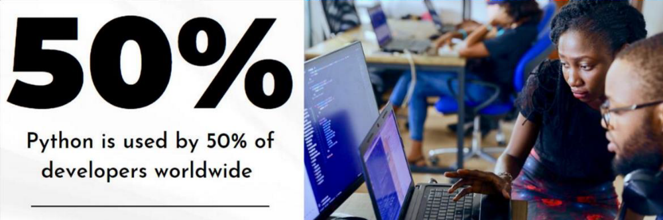

5. Its uncomplicated and Free of cost.
6. Highly supportive and Object – oriented programming.
7. You can compare with any other programming language it is very simple to use

History of Python

Invented in the Netherlands, early 90s by Guido Van Rossum.

Python was conceived in the late 1980s and its implementation was started in December 1989.

Guido Van Rossum is fan of 'Monty Python's Flying Circus', this is a famous TV show in Netherlands.

That is why this programming was given the name Python.

Applications of python

Top 10 Python Applications in Real World.

1.Web Development .
2. Machine Learning and Artificial Intelligence.
3.Data Science.
4.Game Development.
5.Audio and Visual Applications.
6.Software Development.
7.CAD Application.
8.Business Applications.
9. Desktop GUI.
10. Web Scrapping

Execution Of a PYTHON Program :

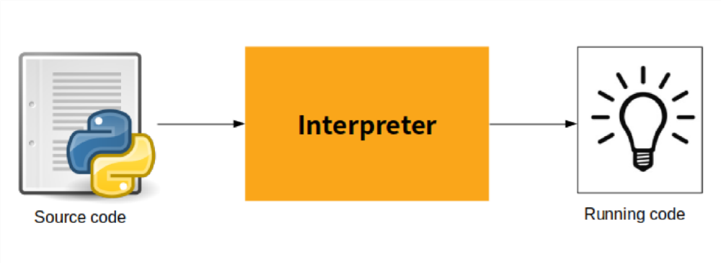

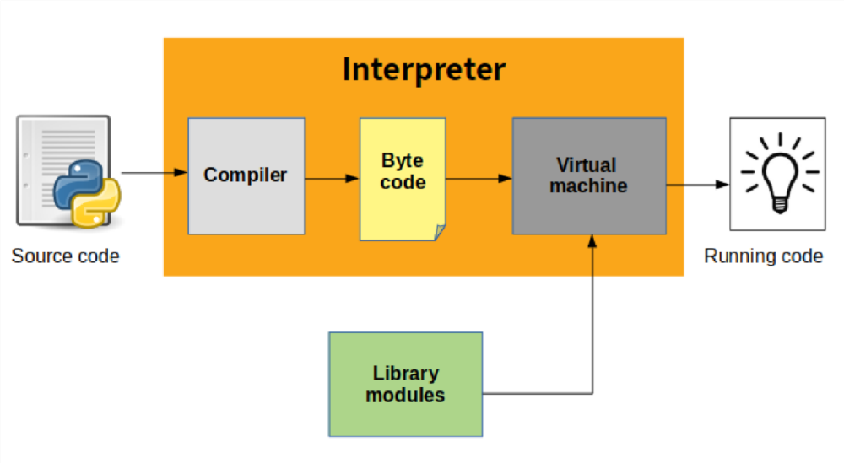

From the figure above, it can be inferred that interpreter is made up of two parts:
• Compiler
• Virtual machine

➢ What does compiler do?

Compiler compiles your source code (the statements in your file) into a format known as byte code. Compilation is simply a translation step!

➢ What does Virtual Machine do?

As soon as source code gets converted to byte code, it is fed into PVM (Python Virtual Machine).
It’s just a big loop that iterates through your byte code instructions, one by one, to carry out their operations. The PVM is the runtime engine of Python; it’s always present as part of the Python system, and is the component that truly

runs your scripts. Technically, it’s just the last step of what is called the Python interpreter.
So, this is how a python interpreter runs your python code!

Comments:

A comment in program is the inclusion of short descriptions along with the code to increase its readability. A developer uses them to write his or her thought process while writing the code. It explains the basic logic behind why a particular line of code was written.

Types:
1. Single line comment --- represent with special symbol - #
2. Multi line comments --- represent with invited quotes with three times-

‘‘‘you have to write comments with in this quotes ’’’

Keywords:

Python keywords are special reserved words that have specific meanings and purposes and can't be used for anything but those specific purposes.
We have 33 keywords in python
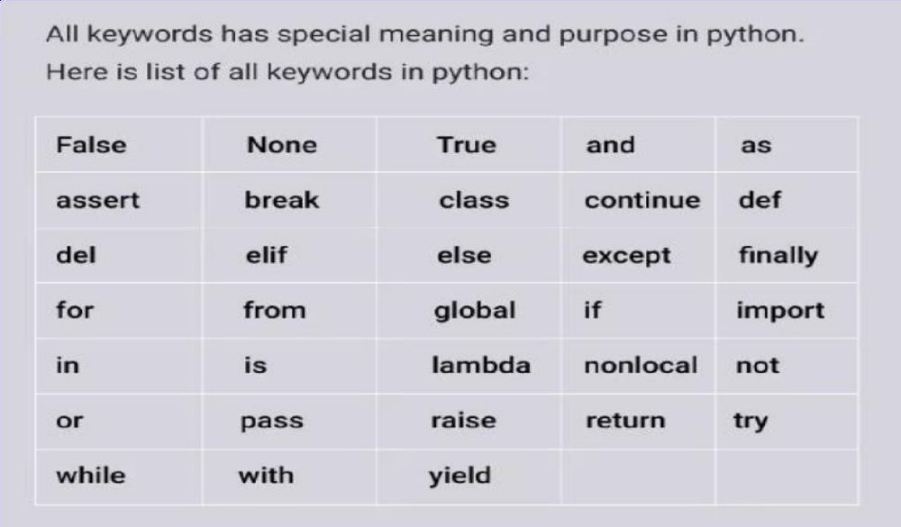

Complete keywords with meanings .
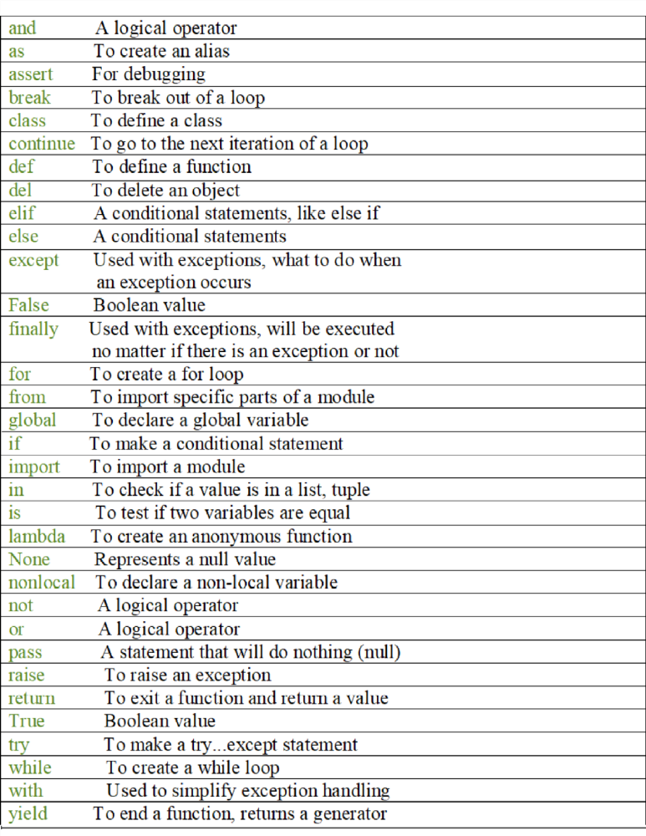

Identifier
Python Identifier is the name we give to identify a variable, function, class, module or other object. That means whenever we want to give an entity a name, that's called identifier.

Rules for Creating Identifiers
1. An identifier it can contains letters (upper & lower case), Numbers and underscore.
2. An identifier should not start with a numerical value. It can start with a letter or an underscore.
3. We should not use any special symbols in between the identifier even whitespace. However, the only underscore symbol is allowed.
4. Keywords should not be used as identifiers.
5. There is no limit for the length of an identifier. However, the compiler considers the first 33 characters only.

6. An identifier must be unique in its scope.

7. Identifier are case – sensitive .

Variables :

Python variables are the reserved memory locations used to stores data values in a Python Program. This means that when you create a variable you reserve some space in the memory.

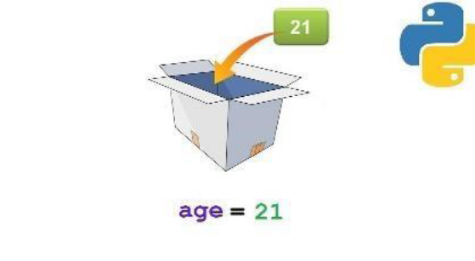

Syntax: Var_name = Value

Ex: Name = “Suresh” - Str

Age = 25 - int

Height = 5.7 - Float

A variable is created the moment you first assign a value to it.

Many Values to Multiple Variables
Python allows you to assign values to multiple variables in one line:

Example
x, y, z = "Orange", "Banana", "Cherry"

print(x)
print(y)
print(z)
Note: Make sure the number of variables matches the number of values, or else you will get an error.

One Value to Multiple Variables
And you can assign the same value to multiple variables in one line:

Example
x = y = z = "Orange"

print(x)
print(y)
print(z)

output
Orange
Orange
Orange

Python - Output Variables

Output Variables
The Python print() function is often used to output variables.
x = "Python is awesome"
print(x)

In the print() function, you output multiple variables, separated by a comma:

Example
x = "Python"
y = "is"
z = "awesome"
print(x, y, z)

Output

Python is awesome

Built-in Data Types

In programming, data type is an important concept.
Variables can store data of different types, and different types can do different things.

Python has the following data types built-in by default, in these categories:

Text Type : | str
Numeric Types : | int, float, complex
Sequence Types : | list, tuple
Mapping Type : | dict
Set Types : | set,
Boolean Type : | bool

Getting the Data Type
You can get the data type of any object by using the type() function:

Example
Print the data type of the variable x:
x = 5
print(type(x))

Output
<class 'int'>

Python Numbers

Python Numbers
There are three numeric types in Python:
- int
- float
- complex
Variables of numeric types are created when you assign a value to them:

Example
x = 1 # int
y = 2.8 # float
z =1+9j # complex
To verify the type of any object in Python, use the type() function:

Example
print(type(x))
print(type(y))
print(type(z))

Int
Int, or integer, is a whole number, positive or negative, without decimals, of unlimited length.

Example
Integers:
x = 1
y = 35656222554887711
z = -3255522
print(type(x))
print(type(y))
print(type(z))

<class 'int'>
<class 'int'>
<class 'int'>

Float
Float, or "floating point number" is a number, positive or negative, containing one or more decimals.

Example
Floats:
x = 1.10
y = 1.0
z = -35.59
print(type(x))
print(type(y))
print(type(z))

Complex
Complex numbers are written with a "j" as the imaginary part:

Example
Complex:
x = 3+5j
y = 5j
z = -5j
print(type(x))
print(type(y))
print(type(z))

Type Conversion
You can convert from one type to another with the int(), float(), and complex() methods:

Example
#convert from int to float:
x = float(1)

#convert from float to int:
y = int(2.8)

#convert from int to complex:
z = complex(1)

print(x)
print(y)
print(z)

print(type(x))
print(type(y))
print(type(z))

Casting
If you want to specify the data type of a variable, this can be done with casting.
Example
x = str(3)
y = int(3)
z = float(3)

print(x)
print(y)
print(z)

Get the Type
You can get the data type of a variable with the type() function.

Example
x = 5
y = "John"
print(type(x))
print(type(y))

Output
<class 'int'>
<class 'str'>

Type Casting in Python (Implicit and Explicit) with Examples

Type Casting is the method to convert the Python variable datatype into a certain data type in order to perform the required operation by users. In this article, we will see the various techniques for typecasting. There can be two types of Type Casting in Python:
- Python Implicit Type Conversion
- Python Explicit Type Conversion

Implicit Type Conversion in Python
In this, method, Python converts the datatype into another datatype automatically. Users don’t have to involve in this process.
Python
# Python program to demonstrate
# implicit type Casting

# Python automatically converts
# a to int
a=7
print(type(a))

# Python automatically converts
# b to float
b=3.0
print(type(b))

# Python automatically converts
# c to float as it is a float addition
c=a+b
print(c)
print(type(c))

# Python automatically converts
# d to float as it is a float multiplication
d=a*b
print(d)
print(type(d))
Output:
<class 'int'>
<class 'float'>
10.0
<class 'float'>
21.0
<class 'float'>

Explicit Type Conversion in Python
In this method, Python needs user involvement to convert the variable data type into the required data type.

Examples of Type Casting in Python
Mainly type casting can be done with these data type functions:
- Int(): Python Int() function take float or string as an argument and returns int type object.
- float(): Python float() function take int or string as an argument and return float type object.
- str(): Python str() function takes float or int as an argument and returns string type object.

Python Convert Int to Float
Here, we are Converting Int to Float in Python with the float() function.
Python
# Python program to demonstrate
# type Casting

# int variable
a=5

# typecast to float
n=float(a)

print(n)
print(type(n))

Output:

5.0
<class 'float'>

String in python

In computer programming, a string is a sequence of characters. For example, "hello" is a string containing a sequence of characters 'h' , 'e' , 'l' , 'l' , and 'o'.

Strings in python are surrounded by either single quotation marks, or double quotation marks.
'hello' is the same as "hello".
You can display a string literal with the print() function:

Example
print("Hello")
print('Hello')

Assign String to a Variable
Assigning a string to a variable is done with the variable name followed by an equal sign and the string:

Example
a = "Hello"
print(a)

Multiline Strings
You can assign a multiline string to a variable by using three quotes:

Example
You can use three double quotes:

a = """Lorem ipsum dolor sit amet,
consecteturadipiscingelit,
sed do eiusmodtemporincididunt
utlabore et dolore magna aliqua."""
print(a)

output
Lorem ipsum dolor sit amet,
consecteturadipiscingelit,
sed do eiusmodtemporincididunt
utlabore et dolore magna aliqua.

Or three single quotes:

Example
a = '''Lorem ipsum dolor sit amet,
consecteturadipiscingelit,
sed do eiusmodtemporincididunt
utlabore et dolore magna aliqua.'''
print(a)

String Length
To get the length of a string, use the len() function.

Example
The len() function returns the length of a string:
a = "Hello, World!"
print(len(a))

output
13

Check String
To check if a certain phrase or character is present in a string, we can use the keyword in.

Example
Check if "free" is present in the following text:
txt = "The best things in life are free!"
print("free" in txt)

output
True

Use it in an if statement:

Example
Print only if "free" is present:
txt = "The best things in life are free!"
if "free" in txt:
print("Yes, 'free' is present.")

output
Yes, 'free' is present.

Check if NOT
To check if a certain phrase or character is NOT present in a string, we can use the keyword not in.

Example
Check if "expensive" is NOT present in the following text:
txt = "The best things in life are free!"
print("expensive" not in txt)

True

Python - Slicing Strings

Slicing
You can return a range of characters by using the slice syntax.
Specify the start index and the end index, separated by a colon, to return a part of the string.

Example
Get the characters from position 2 to position 5 (not included):
b = "Hello, World!"
print(b[2:5])

output

llo

Note: The first character has index 0.

Slice From the Start
By leaving out the start index, the range will start at the first character:

Example
Get the characters from the start to position 5 (not included):
b = "Hello, World!"
print(b[:5])

output
Hello

Slice To the End
By leaving out the end index, the range will go to the end:

Example
Get the characters from position 2, and all the way to the end:
b = "Hello, World!"
print(b[2:])

output

llo, World!

Negative Indexing
Use negative indexes to start the slice from the end of the string:

Example
Get the characters:
From: "o" in "World!" (position -5)
To, but not included: "d" in "World!" (position -2):
b = "Hello, World!"
print(b[-5:-2])

Python - Escape Characters

Escape Character
To insert characters that are illegal in a string, use an escape character.
An escape character is a backslash \ followed by the character you want to insert.
An example of an illegal character is a double quote inside a string that is surrounded by double quotes:
To fix this problem, use the escape character \":

Example
The escape character allows you to use double quotes when you normally would not be allowed:
txt = "We are the so-called \"Vikings\" from the north."

We are the so-called "Vikings" from the north.

Escape Characters
Other escape characters used in Python:
Code | Result | Try it
\' | Single Quote | Try it »
\\ | Backslash | Try it »
\n | New Line | Try it »
\t | Tab | Try it »
\b | Backspace | Try it »

output
orl

capitalize() Method:
The capitalize() method returns a string where the first character is upper case, and the rest is lower case.
txt = "python is FUN!"
x = txt.capitalize()
print (x)

casefold() Method:
The casefold() method returns a string where all the characters are lower case.

txt = "Hello, And Welcome To My World!"
x = txt.casefold()
print(x)
hello, and welcome to my world!

String center() Method:
The center() method will center align the string, using a specified character (space is default) as the fill character.

Syntax
string.center(length, character)

Parameter Values
Parameter | Description
length | Required. The length of the returned string
character | Optional. The character to fill the missing space on each side. Default is " " (space)

Print the word "banana", taking up the space of 20 characters, with "banana" in the middle:

txt = "banana"
x = txt.center(20)
print(x)

banana

count() Method:
The count() method returns the number of times a specified value appears in the string.

Syntax
string.count(value, start, end)

Parameter Values
Parameter | Description
value | Required. A String. The string to value to search for
start | Optional. An Integer. The position to start the search. Default is 0
end | Optional. An Integer. The position to end the search. Default is the end of the string

Return the number of times the value "apple" appears in the string:
txt = "I love apples, apple are my favorite fruit"
x = txt.count("apple")
print(x)

2

Search from position 10 to 24:

txt = "I love apples, apple are my favorite fruit"
x = txt.count("apple", 10, 24)
print(x)
1

startswith() Method:
the startswith() method returns True if the string starts with the specified value, otherwise False.

Syntax
string.startswith(value, start, end)

Parameter Values
Parameter | Description
value | Required. The value to check if the string starts with
start | Optional. An Integer specifying at which position to start the search
end | Optional. An Integer specifying at which position to end the search

Check if the string starts with "Hello":
txt = "Hello, welcome to my world."
x = txt.startswith("Hello")
print(x)

True

Check if position 7 to 20 starts with the characters "wel":
txt = "Hello, welcome to my world."
x = txt.startswith("wel", 7, 20)
print(x)

True

endswith() Method:
The endswith() method returns True if the string ends with the specified value, otherwise False.
Check if the string ends with a punctuation sign (.):
txt = "Hello, welcome to my world."
x = txt.endswith(".")
print(x)

Check if the string ends with the phrase "my world.":
txt = "Hello, welcome to my world."
x = txt.endswith("my world.")
print(x)

Python - String Concatenation

String Concatenation
To concatenate, or combine, two strings you can use the + operator.

Example
Merge variable a with variable b into variable c:
a = "Hello"
b = "World"
c = a + b
print(c)

HelloWorld

Example
To add a space between them, add a " ":
a = "Hello"
b = "World"
c = a + " " + b
print(c)

Hello World

Python - Format - Strings

String Format
As we learned in the Python Variables chapter, we cannot combine strings and numbers like this:

Example
age = 36
txt = "My name is John, I am " + age
print(txt)
But we can combine strings and numbers by using the format() method!
The format() method takes the passed arguments, formats them, and places them in the string where the placeholders {} are:

Example
Use the format() method to insert numbers into strings:
age = 36
txt = "My name is John, and I am {}"
print(txt.format(age))

My name is John, and I am 36

The format() method takes unlimited number of arguments, and are placed into the respective placeholders:

Example
quantity = 3
itemno = 567
price = 49.95
myorder = "I want {} pieces of item {} for {} dollars."
print(myorder.format(quantity, itemno, price))

I want 3 pieces of item 567 for 49.95 dollars.

ou can use index numbers {0} to be sure the arguments are placed in the correct placeholders:

Example
quantity = 3
itemno = 567
price = 49.95
myorder = "I want to pay {2} dollars for {0} pieces of item {1}."
print(myorder.format(quantity, itemno, price))

I want to pay 49.95 dollars for 3 pieces of item 567

Index() Method:
The index() method finds the first occurrence of the specified value.
The index() method raises an exception if the value is not found.
Where in the text is the first occurrence of the letter "e"?:
txt = "Hello, welcome to my world."
x = txt.index("e")
print(x)

isalnum() Method:
The isalnum() method returns True if all the characters are alphanumeric, meaning alphabet letter (a-z) and numbers (0-9).
Example of characters that are not alphanumeric: (space)!#%&? etc.
txt = "Company12"
x = txt.isalnum()
print(x)
True

isalpha() Method:
The isalpha() method returns True if all the characters are alphabet letters (a-z).

txt = "CompanyX"
x = txt.isalpha()
print(x)
True

islower() Method:
The islower() method returns True if all the characters are in lower case, otherwise False.
Numbers, symbols and spaces are not checked, only alphabet characters.
txt = "hello world!"
x = txt.islower()
print(x)

istitle() Method:
The istitle() method returns True if all words in a text start with a upper case letter, AND the rest of the word are lower case letters, otherwise False.
Symbols and numbers are ignored.
Syntax
string.istitle()
Check if each word start with an upper case letter:
txt = "Hello, And Welcome To My World!"
x = txt.istitle()
print(x)
True

strip() Method:
Whitespace is the space before and/or after the actual text, and very often you want to remove this space.

Example
The strip() method removes any whitespace from the beginning or the end:
a = " Hello, World! "
print(a.strip()) # returns "Hello, World!"

split() Method:
The split() method splits a string into a list.
You can specify the separator, default separator is any whitespace.
The split() method returns a list where the text between the specified separator becomes the list items.

Example
The split() method splits the string into substrings if it finds instances of the separator:
a = "Hello, World!"
print(a.split(",")) # returns ['Hello', ' World!']

swapcase() Method:
The swapcase() method returns a string where all the upper case letters are lower case and vice versa.
Syntax
string.swapcase()

txt = "Hello My Name Is PETER"
x = txt.swapcase()
print(x)

hELLOmYnAMEiS peter

zfill() Method:
The zfill() method adds zeros (0) at the beginning of the string, until it reaches the specified length.
If the value of the len parameter is less than the length of the string, no filling is done.

Syntax
string.zfill(len)

Fill the string with zeros until it is 10 characters long:
txt = "50"
x = txt.zfill(10)
print(x)

0000000050

a = "hello"
b = "welcome to the jungle"
c = "10.000"

print(a.zfill(10))
print(b.zfill(10))
print(c.zfill(10))

00000hello
welcome to the jungle
000010.000

Replace String

Example
The replace() method replaces a string with another string:
a = "Hello, World!"
print(a.replace("H", "J"))

Jello, World!

